**Sustainable Smart City Assistant Using IBM Granite LLM**

## Project Overview

## **A** concise, one-page document that provides a high-level summary of a project's goals, objectives, scope, and expected outcomes, serving to align the project team and stakeholders and to.

**Policy Search & Summarization**

A municipal planner uploads a complex city policy document to the assistant’s interface. In seconds, the assistant summarizes it into a concise, citizen-friendly version using IBM Granite LLM. This empowers planners to quickly interpret key points and make informed urban decisions.

## Citizen Feedback

A resident notices a burst water pipe on a city street. Instead of calling helplines, they submit a report through the assistant’s feedback form. The issue is logged instantly with category tagging (e.g., "Water") and can be reviewed by city administrators.

## KPI Forecasting

A city administrator uploads last year’s water usage KPI CSV. The assistant forecasts next year’s consumption using built-in machine learning. This data is used in planning budgets and infrastructure upgrades.

### Architecture

The architecture consists of three main layers:

1. Frontend (Streamlit): Provides a modular dashboard with options to view KPIs, submit feedback, interact with chat assistant, search policy vectors, generate reports, and fetch eco tips.
2. Backend (FastAPI): Manages API requests, handles file uploads, and integrates with ML models, Pinecone, and Watsonx Granite LLM.
3. External Services: IBM Watsonx for LLM prompts, Pinecone for vector indexing &

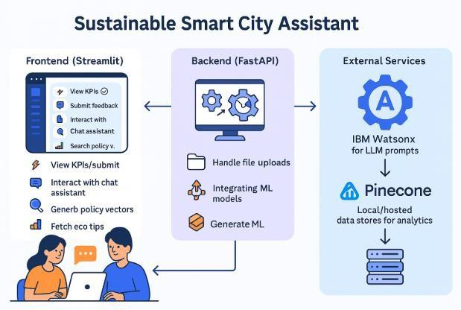

### Project Flow

#### User Input:

Users interact with the **Streamlit frontend dashboard**, where they can:

* Submit **textual prompts** (for chat or policy summaries).
* Upload **policy documents** (.txt, .csv) for summarization and vector search.

## Backend Processing (FastAPI):

Each input request is sent to corresponding **FastAPI endpoints**, where:

* Feedback is stored and categorized through feedback_router.py.
* KPI .csv files are forecasted using internal ML models in kpi_file_forecaster.py.
* Text prompts (from chat, summarizer, eco tips) are sent to **IBM Granite LLM** using the granite_llm.py service.

## AI Response Generation:

* + The **Watsonx Granite LLM** processes chat queries, summaries, eco tips, and generates human-like natural language responses.
  + **Pinecone** retrieves the most relevant policy document chunks using semantic search powered by vector similarity

## Frontend Display:

The **Streamlit frontend** dynamically renders:

* KPI data in **visually enhanced cards** (summary_card.py).
* AI-generated responses (chat, eco tips) directly in user input sections.
* Policy search results in readable formats.
* Submission success or errors through toast messages (e.g., feedback success).

## User Interaction:

Users are able to:

* Switch cities and compare urban KPIs dynamically.
* Ask follow-up queries in the chat assistant.
* Generate policy summaries and sustainability reports.

### Prior Knowledge

the information, understanding, or experience a person already possesses about a topic before learning new information or engaging with a new situation.

### Project Milestones & Development Flow

Project milestones are significant checkpoints or events that mark key achievements and progress in a project's development flow.

Project Milestones

* **Definition:**

Milestones are specific, time-bound events that signify progress toward a project's goal.

* **Purpose:**

They act as navigational aids, providing key reference points to measure success, ensure alignment with goals, and keep the project on schedule.

* **Examples:**
  + Project kickoff
  + Client or stakeholder approval
  + Completion of a major design phase
  + Development Flow & Milestones

The development flow is the sequence of steps a project takes, and milestones are integrated to mark progress through this flow.

1. **1. Initiation:**

The project begins, involving defining goals and scope.

* + **Milestone:** Project officially begins.

1. **2. Planning:**

Detailed planning of phases and deliverables.

* + **Milestone:** Final project plan approved, [requirements document](https://www.google.com/search?rlz=1C1MRUS_enIN1156IN1156&cs=0&sca_esv=083780a269a3263d&sxsrf=AE3TifOKlNt8yGbICo_v4-2xgt0wcAjw6A%3A1757318003738&q=requirements+document&sa=X&ved=2ahUKEwiA2rna18iPAxVeRmwGHTv4AOAQxccNegQITRAB&mstk=AUtExfC7mmQmydC_Yh6-bgANfVmijnr-k5P4lal5GKOTlpzEuuEILOHINqL_tuiRFHxi57pfmYxblO_KJR9EUWShzuQkKHrfK__47_iw06qNu6N-RV4OcS-_Rb0ekAU7WFCkJOYeKaKuoLqcXRWLWNlKI9Ku7fcDBndNXkxXbE8LQUwQr3raL9OqEZNx6LaZgDMFsiSLcLvodj3v8Y1g-7GZhYN68UtYC2vBZRJ5aQswbY_1iVjHwr_87nBHGwmkyqHqRqXs3IHcqNlN22jcwgS1mjoo&csui=3) completed.

1. **3. Execution:**

Tasks are completed, and the core work is performed.

* + **Milestone:** Significant component delivered, key features developed.

1. **4. Monitoring & Controlling:**

Progress is tracked against the plan.

* + **Milestone:** Phase-gate review completed, external approvals obtained.

1. **5. Closure:**

Final deliverables are delivered and the project is formally concluded.

* + **Milestone:** Project successfully deployed, final report submitted.

### Milestone 1: Requirements Specification

**Objective:** Establish the foundational libraries and packages for both frontend and backend to ensure reproducibility and easy environment setup.

### Activity 1: Create requirements.txt

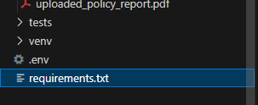

### Activity 2: Install all dependencies

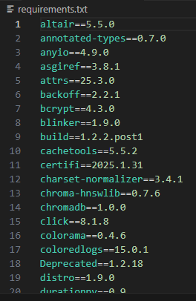

### Milestone 2: Environment Initialization & API Key Setup

**Objective:** Configure and secure external service credentials (Watsonx & Pinecone).

### Activity 1: Generate API Keys

* Watsonx Granite credentials from IBM Cloud dashboard
* Pinecone API key and environment from [https://app.pinecone.io](https://app.pinecone.io/)

### Activity 2: Define .env File

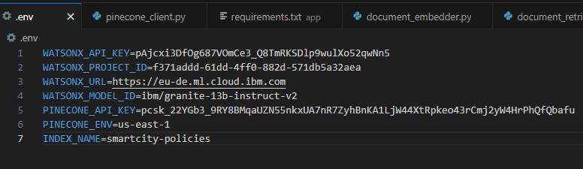

### Milestone 3: AI Model Integration

**Objective:** Integrate Watsonx Granite LLM with a centralized service layer.

### Activity 1: Watsonx Integration

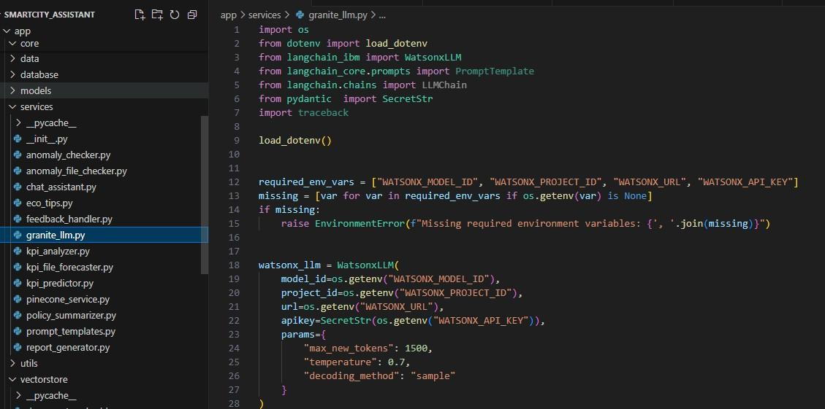

### Activity 2: Implement LLM Service Functions

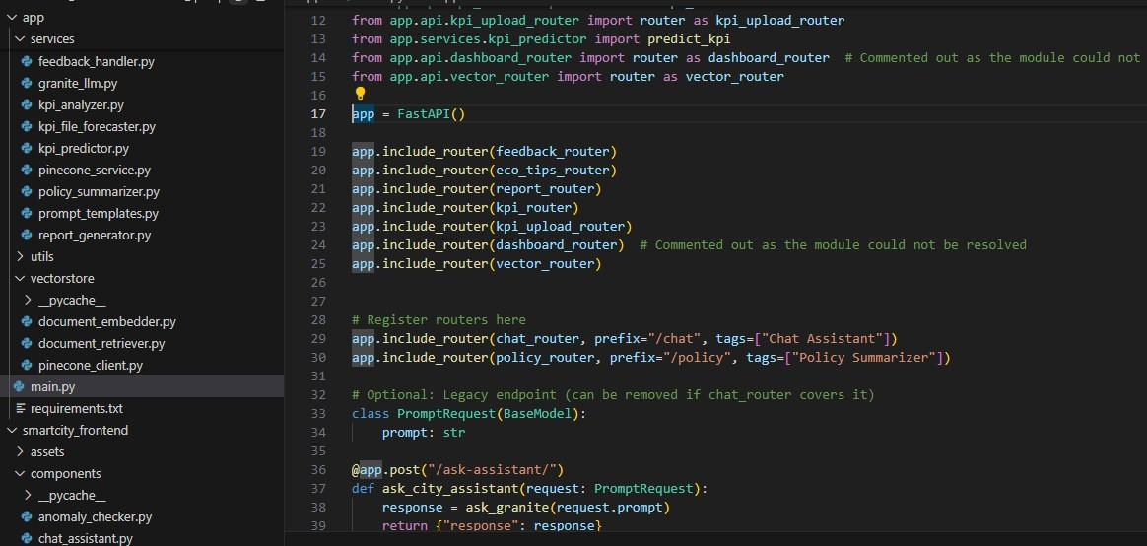

### Milestone 4: Backend API Development

**Objective:** Build modular RESTful API routes using FastAPI.

### Activity 1: Create Routers

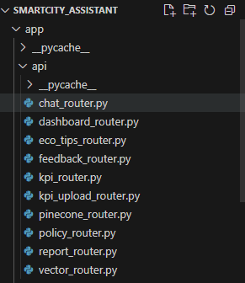

### Activity 2: Test Routes

Use Swagger UI to validate:

* POST /upload-doc
* GET /search-docs



### Milestone 5: Streamlit Frontend UI Development

**Objective:** Design a user-friendly dashboard for real-time interaction.

### Activity 1: Page Structure

* Sidebar navigation using streamlit-option-menu
* Separate pages for: Dashboard, Feedback, Eco Tips, Chat, Policy Search, Anomaly Checker, KPI Forecasting

### Milestone 6: Pinecone Semantic Search Integration

**Objective:** Embed uploaded documents and enable semantic policy

search. **Document Embedding**

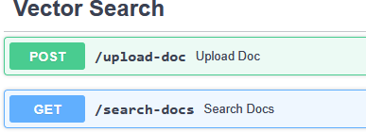

### Milestone 7: ML-based Forecasting and Anomaly Detection

**Objective:** Analyze uploaded CSV files and predict future trends or irregularities.

### Activity 1: Forecasting

### https://lh7-rt.googleusercontent.com/docsz/AD_4nXe6m1i0B_wsfxzMNfgbLj6EvFTZVZSpSB2R89chXGaBJS4oxyZJ8aagoJVQpPNS1o0BZDAa0anFWvhFdWSCcr6D0-OyrB1hVi1EkY28uakRUJaIIqSqhuXdO-Yo9hpocLzVvvfNl82OskKSsg_xk_U?key=vn83EcOjNhmsp5a64lam7kFx

### Activity 2: Anomaly Detection

### https://lh7-rt.googleusercontent.com/docsz/AD_4nXcHmImGaciJ6xzua2mZ6GxS9O2NhD92dgARCLH454SPJo_KpQksWgfc44IW707N8i1PnZ3d-T4TXbCz_OFSzJsy977hVBcMPP4K9e0FuxS466QuCIb75eJABSOiC5431Ua6NDq6LTjdj-POofllSM8?key=vn83EcOjNhmsp5a64lam7kFx

### Milestone 8: Sustainability Report Generation

**Objective:** Generate a city-wise AI-powered sustainability summary.

### Activity 1: Prompt Engineering

* report_generator.py uses a custom prompt to generate an AI-written report from KPI inputs

### Activity 2: Display/Download

### https://lh7-rt.googleusercontent.com/docsz/AD_4nXcQ_n1wFdJte2o_33tC0NcVZ4b3PVTxBwfTyXvVK7dDxksBgd9eZBSm1cpI6ff5d-TMtI1mg3HvftnMmRXv7tf3O9iiCOfPNXteR7ObTO3jqZuggmBzT83-MvvPt7X8D7X9dn7rINFTGJae1C36Yg?key=vn83EcOjNhmsp5a64lam7kFx

### Milestone 9: Chat Assistant Creation

Objective: Build an interactive chat module where users can ask AI-driven questions related to sustainability, city governance, and smart living—powered by IBM Watsonx Granite LLM.

### Activity 1: Define Backend Route

### https://lh7-rt.googleusercontent.com/docsz/AD_4nXccspYhZzY6y1ofA0a6hNoFxoSMKkvwgMi12w0DLM8xLWZGWgQToHnK2nMajPzBg6AcVBgBiZlHl8G-uU3-VQLvOyj9uvPMJaGVKU35UTrPkdQX10aKY3a_pw7eBEyPBwAEm3V6QyWC8YaG5Mr_vA?key=vn83EcOjNhmsp5a64lam7kFx Milestone 10: Final Integration & Testing

**Objective:** Ensure smooth interaction across modules.

### Activity 1: Connect All Pages

* Navigation working via sidebar
* Real-time API interactions tested

### Activity 2: Run Final Test

### https://lh7-rt.googleusercontent.com/docsz/AD_4nXcMeccMhSpPu0xXSBRc2eLgHqA2c19z54dmxao1TTStvLwsjWPWFSJeF4m0QiWklED3QCvXxMMxZXsQ_tSQG1P-WDAXz489oBb92Av8RZq0LFpWW-K2elwPtL2kHyfrESpqsnKJBtIrKkCYkXCxMS4?key=vn83EcOjNhmsp5a64lam7kFx